**MAWLANA BHASHANI SCIENCE AND TECHNOLOGY UNIVERSITY**

SANTOSH, TANGAIL-1902



DEPARTMENT OF INFORMATION AND COMMUNICATION TECHNOLOGY

**Course Title: Computer Based Numerical Method Lab**

**Course Code: ICT-2102**

**Lab Report on: Plotting Sine and Cosine Waves in MATLAB**

**Lab Report No: 01**

|  |  |
| --- | --- |
| Submitted By | Submitted To |
| Name: Kuldip Saha Mugdha  ID: IT22018  2nd Year, 1st Semester  Session: 2021-2022  Dept. of ICT, MBSTU | Dr. Mst. Nargis Akter  Professor  DEPARTMENT OF INFORMATION AND COMMUNICATION TECHNOLOGY  MAWLANA BHASHANI SCIENCE AND TECHNOLOGY UNIVERSITY |

**Date of Performance:**

**Date of Submission:**

**Experiment No : 01**

**Experiment Name: Plotting Sine and Cosine Waves in MATLAB**

**Objective:**

The objective of this experiment is to plot the sine and cosine functions separately using MATLAB and understand their waveforms.

**Materials:**

* MATLAB software installed on a computer

**Code, Procedure, and Output:**

**Plotting sin(x) from 0 to 2π**

In this part, we will plot the sine function for values of x ranging from 0 to 2π. This will generate a simple sine wave.

**Code:**

x = 0:0.01:2*pi; % x values from 0 to 2π, with a step of 0.01

y = sin(x); % Calculate sine of x

plot(x, y); % Plot x vs. y

xlabel('x'); % Label for x-axis

ylabel('sin(x)'); % Label for y-axis

title('Sine Wave'); % Title for the plot

**Output:**

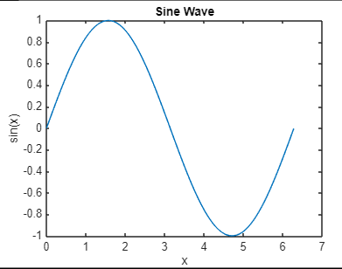

### ****Plotting**** cos(x) ****from 0 to 2π****

In this part, we will plot the cosine function for values of x ranging from 0 to 2π. This will generate a simple cosine wave.

**Code:**

x = 0:0.01:2*pi; % x values from 0 to 2π, with a step of 0.01

y = cos(x); % Calculate cosine of x

plot(x, y); % Plot x vs. y

xlabel('x'); % Label for x-axis

ylabel('cos(x)'); % Label for y-axis

title('Cosine Wave'); % Title for the plot

**Output:**

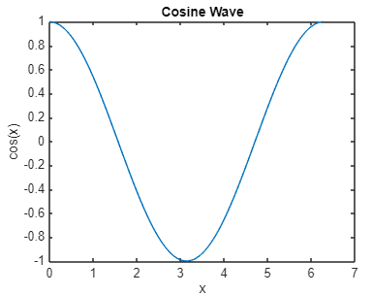

#### Discussion:

* **Sine Wave:** The plot of sin(x) shows a smooth oscillation starting from 0, reaching a maximum of 1 at x = π/2, a minimum of -1 at x = 3π/2, and completing one full cycle at x = 2π. This behavior reflects the periodic nature of the sine function.
* **Cosine Wave:** The plot of cos(x) shows a similar oscillation, but it starts at 1 when x = 0, reaches a minimum of -1 at x = π, and completes one cycle at x = 2π. The cosine function is essentially a phase-shifted version of the sine function by π/2.
* **Periodicity:** Both sine and cosine functions are periodic with a period of 2π, meaning they repeat their values every 2π units along the x-axis.
* **Amplitude:** Both functions oscillate between -1 and 1, representing their amplitude.